**Information Engineering Planning**

1. Strategic Planning factors

* Goals (organisational goals)
* Critical success factors
* Problem areas

**Read Page 39 of the Text Book**

1. Corporate planning Objects

* Organisational units
* Locations
* Business functions
* Entity Types

**Read Page 40 of the Text Book**

1. Develop EER model

* Functional decomposition
* Planning Matrices (Function-to-data entity, Location-to-function, Unit-to-function)
* Entity Relationship Diagram

**Online Reading**

<http://www.slideshare.net/BlackIce86/modern-database-management-jeffrey-a-hoffer-mary-b-prescott>

<http://en.tjcities.com/wp-content/uploads/Books/Database_10th.pdf>

**Functional Decomposition**

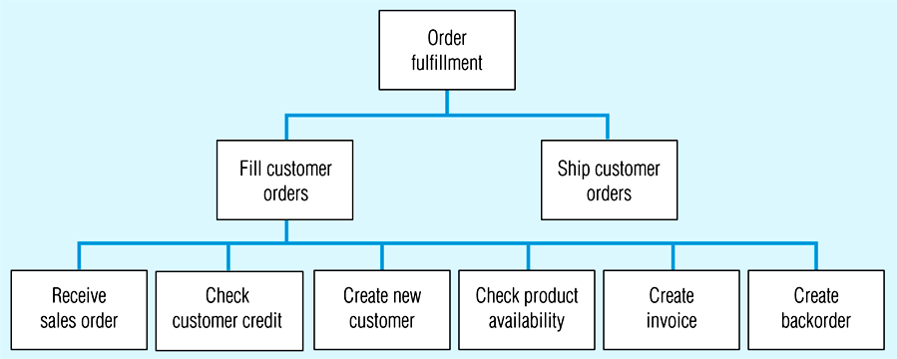

**Function-to-data entity**

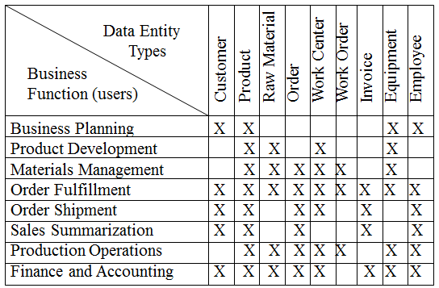

**Read Page 93 of the Text Book**